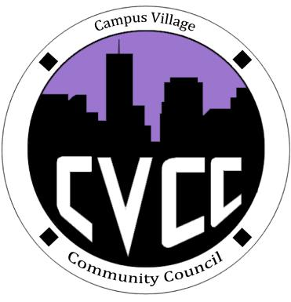
Engagement Meeting Minutes
September 30th, 2014

- Start Time: 7:03pm
- Role Call:
  - President – Present
  - Vice President – Present
  - National Communications Coordinator – Present
  - Treasurer – Present
  - Secretary – N/A
  - Marketing Coordinator – Present
  - Marketing Representative - Present
  - Advisor – Present
- Residents:
- Executive Board Reports:
- Old Business:
- OTM’s
  - Will be discussed on Friday
- Halloween Dance
  - October 30th 8pm-12am, Set up: 6:30
  - Flyers need to be ready by Tuesday
  - Dance Suggestions:
    - Costume contest: w/ prizes i.e. movie tickets w/ popcorn and candy, Beats headphones, Kindle, Halloween bucket
    - Overall best costume, most creative, scariest
    - Scratch the hot chocolate, replace w/ punch and dry ice, Hawaiian punch, sprite, sherbet, dry ice, Halloween cups, liters of soda instead of cans, napkins, plates, chips, Halloween cupcakes and cookies
    - Tissue ghosts
- New Business:
- Town Hall
  - Voted on food for Town Hall, was approved
  - Decorations for Town Hall, was approved
  - T-shirts, was approved
- Website:
  - First name, school, fun fact, why be a part of counsel, one goal for counsel – Email to Darius
- E-Board Meeting:
  - OTM’s, think of partners
  - Bids will be due on the 15th
  - Expectations
  - Continue on goals
  - Thanksgiving Dinner
  - We need a secretary
- Advisor Remarks:

Adjourned: 8:00pm

