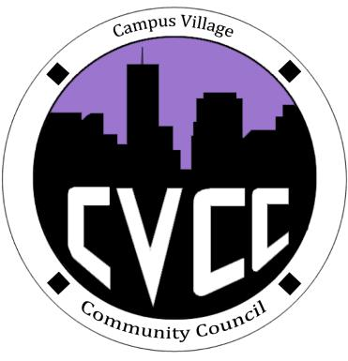
Engagement Meeting Minutes
September 23rd, 2014

- START TIME: 7:06pm
- Role Call:
  - President – Present
  - Vice President – Present
  - National Communications Coordinator – Present
  - Treasurer – Present
  - Secretary – N/A
  - Marketing Coordinator – Present
  - Marketing Representative - Present
  - Advisor – Present
- Residents:
- Executive Board Reports:
- Old Business:
- September Town Hall:
  - Town Hall went well, residents voiced their concerns, residents opened up to us
  - We should talk amongst tables to document resident concerns, figure out how to eliminate the side conversations that went on while other residents were voicing their concerns
  - Lots of positive feedback, overall went really well
  - Set-up and clean-up went well
  - Allow the residents with time to discuss amongst themselves their issues before having them documented
  - Comment box we can review the following Tuesday meetings
  - Kelsey: went well, good turn out, we did a good job!
- Halloween Dance:
  - Date change: Oct. 30th
  - Snack table: blacklighting, popcorn, candy, soda, rice krispy, dry ice, hot chocolate, pumpkin seeds
  - Pumpkin carving (10 pumpkins)
  - Purple, black, orange – fog machine, spider webs, spider rings and vampire teeth, black table covers, purple and orange streamers, ghosts, skeletons, grave stones
  - Costume contest: 4 movie tickets, 2 movie boxes
- New Business:
- IACURH:
  - Scholarship
  - Swag
- Halley’s Halloween funding request:
  - Approved
- Program and RA of the year:
  - Frank’s Talent Night
  - Halley
- Advisor Remarks:

Adjourned: 8:43pm

