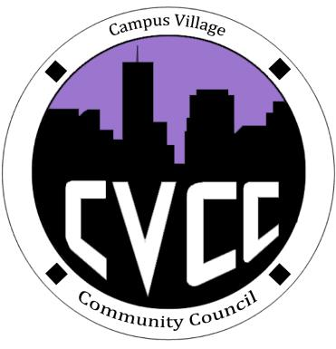
Engagement Meeting Minutes
September 2nd, 2014

- Start Time: 7:05pm

- Role Call:
  - President – Present
  - Vice President – N/A
  - National Communications Coordinator – Present
  - Treasurer – Present
  - Secretary – N/A
  - Marketing Coordinator – Present
  - Marketing Representative - Present
  - Advisor - Present

- Introductions:
  - Everyone introduced themselves
    - Executive Board
    - Marco Lopez – RA
    - Nathan Sebastian – RA
    - Frank Winchester – RA
    - Julia - Resident

  - Induction Ceremony
    - Advisor inducted the new Executive Board Members
      - President
      - National Communications Coordinator
      - Treasurer
      - Marketing Coordinator
      - Marketing Representative

- Townhall
  - Discussed Themes
    - Under the Sea
    - South of the Boarder (Mexican Food)
    - 80’s Neon Themed (Burgers and Wings)
    - Great Gatsby (Italian Food)
    - Football Season (Burgers and Wings) Bronco’s Themed
    - Country Themed
  - Discussed Decorations
    - Record Player
    - Plastic Wine Glasses
    - Black and Gold Streamers
    - Black table tops
    - Gold plate ware
    - Jewels for tables
    - Skylines for decorations
  - Food
    - Chocolate Fondue & Strawberries
    - Angel Food Cake
    - Sparkling grape Juice & Cider
  - Advertisements
    - Lobby Poster Large Silhouette
    - 8x1/2 by 11 advertisements
    - Will finalize at next Engagement Meeting
- Questions

- End Time: 7:59pm

