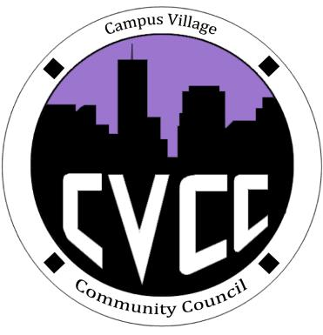
Engagement Meeting Minutes
August 26th, 2014

- Start Time:

- Icebreaker: Kelsey

  - Introduce yourself, the position you are running for and one fun fact about yourself

- Role Call:
  - President - Present
  - National Communications Coordinator - Present
  - Advisor - Present

- Introductions:
  - President: Kelsey
  - National Communications Coordinator: Alirio
  - Advisor: Russell
  - Residents who attended
    - Mattie wants to run a resort
    - John wants to be a pharmacist
    - Darius wants to draw video game animations

- Community Council
  - Discuss what we do
    - Kelsey discussed Townhall Meetings and being the voice for the students
  - Engagement meetings
    - Tuesdays @ 7pm
  - Townhall meetings
    - What they are for
    - Every 3rd Thursday of each month @ 7:30pm
    - September Townhall Meeting is 9/18/2014 @ 7:30pm
  - Executive Board Meetings
    - Weekly events time and day to be determined
  - Website/Facebook

- IACURH/NACURH
  - IDAHO Update
    - Russell talked about the IACURH Conference and how much fun it is going to be
- Interview Sign Up
  - 2 time slots, 30 min
  - 26th – 29th
  - Business casual attire

- Questions

- End Time: 8:06pm

