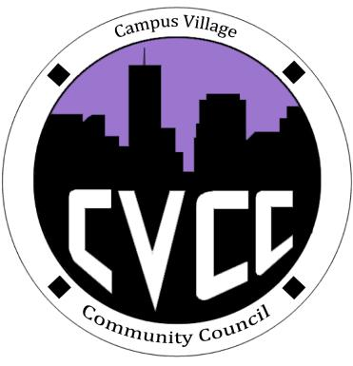
Engagement Meeting Minutes
October 14th, 2014

- Start Time: 7:03pm
- Role Call:
  - President – Present
  - Vice President – Present
  - National Communications Coordinator – Present
  - Treasurer – Present
  - Secretary – N/A
  - Marketing Coordinator – Present
  - Marketing Representative - Present
  - Advisor – Present
- Residents:
- Executive Board Reports:
  - Sierra: Playlist and reformatting minutes
  - Alirio: OTM’s need to be reviewed, one for Kelsey and one for Maddie, IACURH committee conference calls
  - Maddie: Lobby posters, preparing for Town Hall, cricket went down
  - John: received receipts and funding requests that will need to be put into budget
  - Darius: has been updating website, revised Town Hall poster, updated Facebook page, worked on funding request for Engagement meeting poster
  - Kelsey: has been working with Sierra and Russell on Town Hall rules, funding requests for IACURH, three-year plan for goals
- Old Business:
  - Halloween Dance
    - Halloween Dance Set up @ 6pm
    - Sierra, Darius, Maddie, Mark, Nick can help set up
    - Darius, John, Maddie, Sierra, Alirio, Mark, Nick can help during
    - Daris, John, Maddie, Sierra, Alirio, Mark, Nick can help tear down
  - Town Hall
    - Set up @ 6 pm
    - Refer to schedule
    - Cutting out bats
- New Business:
  - Sierra gave update on Halloween Dance DJ
  - Kelsey gave funding request for IACURH shirts and pins: Approved
  - Alirio: advertise on napkin inserts in cafeteria
- Advisor Updates
  - Kelsey, Maddie, and Darius are going to IACURH
  - We are now 4th in Banana Points
  - We’re registered and paid for IACURH
  - Flights have been purchased
  - Working on bids and OTM’s
  - Town Hall we’re doing really good
  - Dance: 2 RA’s have volunteered to help out
  - Polo’s we’re waiting on a proof
  - Hopefully we’ll have a secretary soon
  - Kudos to everyone for being awesome

Adjourned: 8:06pm

