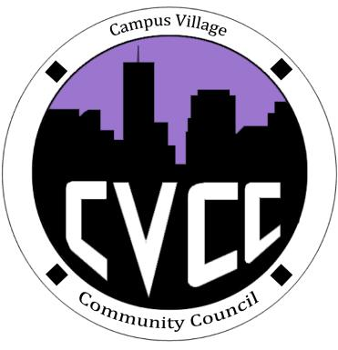

Start Time:

Role Call:

* President
* Vice President
* NCC
* Treasurer
* Secretary
* Marketing Coordinator
* Marketing Representative

Executive Member Updates:

Budget Update:

Old Business:

* Town Hall Discussion
* Super Bowl Party
* Goals

New Business:

* Chinese New Year
* Possible January Event
* Gift Card

Open Floor:

Advisor Remarks:

End Time:

There’s something about a holiday that isn’t all about how much money you spend.

-Burton

Sharing the holiday with other people, and feeling that you’re giving of yourself, gets you past all the commercialism

-Kennedy

**Upcoming Events**

Circuit Training Class:

* December 19th, 5:30PM

Engagement Meeting:

* January 27th, 7:00PM

Open Mic Night:

* December 3rd, 5:00PM

Fun Fit Friday: Total Fitness

* December 5th, 12:00PM

**Campus Village Community Council Engagement Meeting**

December 2nd, 2014