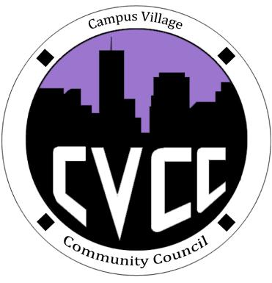
Engagement Meeting Agenda
August 26th, 2014

- Start Time:

- Icebreaker: Kelsey

- Role Call:
  - President
  - National Communications Coordinator
  - Advisor

- Introductions:
  - President: Kelsey
  - National Communications Coordinator: Alirio
  - Advisor: Russell
  - Residents who attended

- Community Council
  - Discuss what we do
  - Engagement meetings
    - Tuesdays @ 7pm
  - Townhall meetings
    - What they are for
    - Every 3rd Thursday of each month @ 7:30pm
  - Executive Board Meetings
    - Weekly events time and day to be determined
  - Website/Facebook

- IACURH/NACURH
  - IDAHO Update
- Interview Sign Up
  - 2 time slots, 30 min
  - 26th – 29th
  - Business casual attire

- Questions

- End Time:

