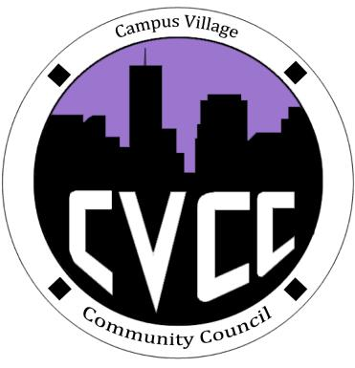

**Upcoming Events**

Pie an RA

* Sunday 16th, 5PM-7PM

November Town Hall

* November 20th, 7:30PM

Engagement Meeting

* November 18th, 7PM

Thanksgiving Dinner

* November 27th,

1PM-3PM

Feel the Soul

* November 13th, 8:30PM

Seeds need many things to successfully grow, develop and blossom

-IACURH 2014

Start Time:

Role Call:

* President
* Vice President
* NCC
* Treasurer
* Secretary
* Marketing Coordinator
* Marketing Representative

Executive Board Updates:

Budget Update: YTD $4,418.79

Old Business:

* Group Updates
* Strategic Goals Updates

New Business:

* Super Bowl Party/ Chinese New Year
* Town Hall Discussion
* Pie an RA Event

Funding Requests:

* Mark
* Kelsey

Open Floor:

Advisor Remarks:

End Time:

Campus Village Community Council Engagement Meeting

November 11th, 2014