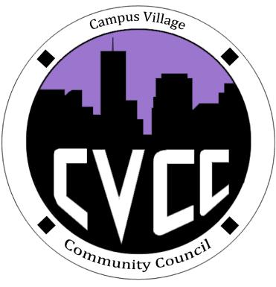

Congratulations on your Community Council Positions:

Nick—Treasurer

It’s the steady, quiet, plodding ones who win in the lifelong race.

-Robert Service

Thanksgiving Dinner:

* Nov. 27th, 1-3PM

Town Hall:

* Nov. 20th, 7:30PM

Friends and Finals:

* Nov. 19th, 7PM

Global Health Symposium

* Nov. 21st, 2014

Upcoming Events

Campus Village Community Council Engagement Meeting

November 18th, 2014

Start Time:

Role Call:

* President
* Vice President
* NCC
* Treasurer
* Secretary
* Marketing Coordinator
* Marketing Representative

Executive Board Updates:

Budget Update:

Old Business:

* Strategic Goals

New Business:

* Pie an RA Discussion
* Town Hall Finalization
* Super Bowl Party

Open Floor:

Advisor Remarks:

End Time: