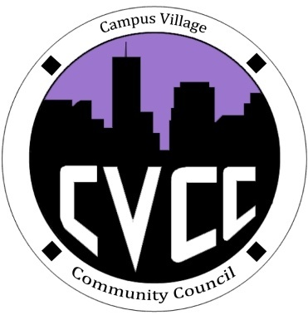

Community Council Agenda
Friday, February 21, 2014

- Call to Order:
- Roll Call:
- President
- Vice-President
- Treasurer
- Secretary
- Marketing Coordinator
- Marketing Representative
- Financial Report
- Budget Update
- Funding Requests
- Unfinished Business:
- CVCC Engagement- Tuesday, Feb. 25 at 7:30pm in the Classroom
- Barbara-Ice Cream Budget Proposal
- Recycle Mania- March 1st -19th
- Prize for winning floor
- Typed up rules to distribute
- StrengthsFinder
- Floor Representative Update
- New Business:
- Voting procedures- amendments, seconding, funding requests/proposals
- Speaker’s list
- From the Floor:
- Advisor Remarks:
- Adjournment:

