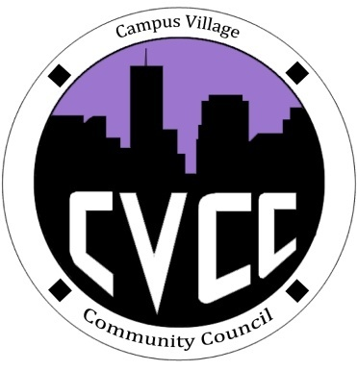

Community Council Agenda
Sunday, December 1, 2013

- Call to Order:
- Roll Call:
- President
- Vice-President
- Treasurer
- Secretary
- Marketing Coordinator
- Marketing Representative
- Unfinished Business:
- November Events
- Thanksgiving Lunch Evaluation
- December Events
- Grocery Bingo: December 5th at 9:00pm in Cafeteria
- Set-up at 8:15pm
- Advertisement Efforts
- Mandatory CVCC Retreat: Saturday, Jan. 25 & Sunday, Jan. 26
- CVCC Polo and Sweatshirt Budget Proposal
- Promotional item Budget Proposal
- Tablecloth Budget Proposal
- New Business:
- Budget Update
- No Frills Budget Proposal
- Robert’s Rules of Order Budget Proposal
- Funding Requests
- From the Floor:
- Advisor Remarks:
- Adjournment:

