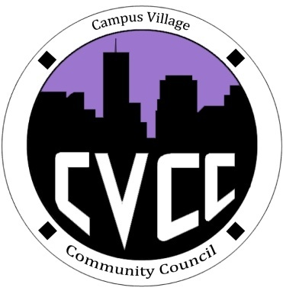

Community Council Agenda
Sunday, November 17, 2013

- Call to Order:
- Roll Call:
- President
- Vice-President
- Treasurer
- Secretary
- Marketing Coordinator
- Marketing Representative
- Icebreaker- Kayla
- Unfinished Business:
- November Events
- Townhall Meeting Evaluation
- Thanksgiving Lunch: November 28th from 11am-1pm
- Boston Market Catering Budget Proposal
- Advertisement Efforts
- December Events
- Grocery Bingo: December 5th at 9:00pm in Cafeteria
- Set-up at 8:15pm
- Budget Proposal for Prizes and Drinks
- Advertisement Efforts
C. CVCC Polo and Sweatshirt Budget Proposal
- New Business:
- Ideas for promotional items for next semester
- Mandatory CVCC Retreat: Saturday, Jan. 25 & Sunday, Jan. 26
- Budget Update
- Funding Requests
- From the Floor:
- Advisor Remarks:
- Adjournment:

