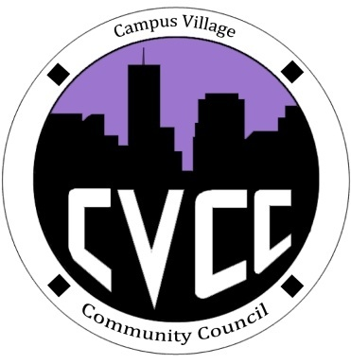

Community Council Agenda
Sunday, November 3, 2013

- Call to Order:
- Roll Call:
- President
- Vice-President
- Treasurer
- Secretary
- Marketing Coordinator
- Marketing Representative
- Icebreaker-De’Andre
- Unfinished Business:
- November Events
- Townhall Meeting: November 14th at 5:30pm
- Set-up at 5pm
- Qdoba Catering- Taco Bar (Around $300 for 30 people)
- Drinks- leftover soda, Gatorade tub with ice water
- Doorknock Schedule
- December Events
- Grocery Bingo: December 5th at 9:00pm
- Set-up at 8:15pm
- Cafeteria
- New Business:
- November Events
- Thanksgiving Lunch: November 28th from 11am-1pm
- Food/Drinks?
- Budget Update
- Funding Requests
- From the Floor:
- Advisor Remarks:
- Adjournment:

