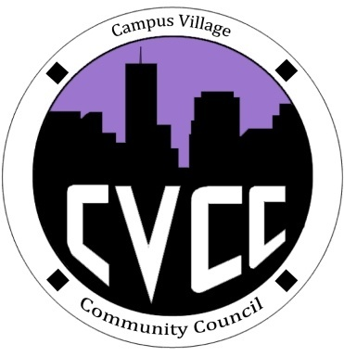

Community Council Agenda
Sunday, October 27, 2013

- Call to Order:
- Roll Call:
- President
- Vice-President
- Treasurer
- Secretary
- Marketing Coordinator
- Marketing Representative
- Unfinished Business:
- October Events
- Hallo-Scream Party Evaluation
- New Business:
- November Events
- Townhall Meeting: November 14 at 5:30pm
- Food/Drinks
- Main topic or theme?
- Advertising efforts
- Grievances
- Budget Update
- Funding Requests
- From the Floor:
- Advisor Remarks:
- Adjournment:

