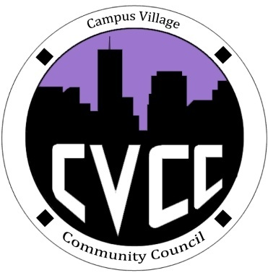

Community Council Agenda
Sunday, October 20, 2013

- Call to Order:
- Roll Call:
- President
- Vice-President
- Treasurer
- Secretary
- Marketing Coordinator
- Marketing Representative
- Unfinished Business:
- October Events
- Hallo-Scream Party: October 24 @ 9pm (set-up at 6:30pm)
- Music
- Food/Candy
- Drinks
- Decorations
- Gift baskets for costume contest winners
- New Business:
- Budget Update
- Funding Requests
- From the Floor:
- Advisor Remarks:
- Adjournment:

