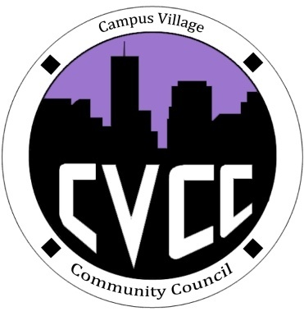

Community Council Agenda
Sunday, October 13, 2013

- Call to Order:
- Roll Call:
- President
- Vice-President
- Treasurer
- Secretary
- Marketing Coordinator
- Marketing Representative
- Icebreaker-Kayla
- Unfinished Business:
- October Events
- Art Appreciation Week Evaluation
- Hallo-Scream Party: October 24 @ 9am (set-up at 7:30pm)
- Executive Board Member Budget Proposals
- Costume Contest
- Advertising Efforts
- Recycling Project/Recycling Awareness Week (Nov.11-15?)
- Ideas?
- Executive Board Gifts
- New Business:
- Budget Update
- Funding Requests
- From the Floor:
- Advisor Remarks:
- Adjournment:

