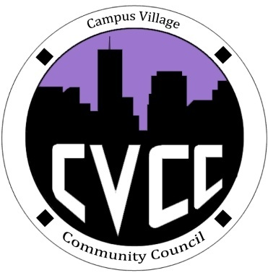

Townhall Meeting 10/10/13 Agenda

7:00-7:10pm: Arrival
7:10-7:15pm: Welcome and Introductions
7:15-7:30pm: Edible Art: Decorate your own cupcake/Vote on Artwork
7:30-7:40pm: CVA Management Recap on last month’s concerns
- CVCC-Recycling
- Russell-Elauwit
- Tad-Sodexo
7:40-8:00pm: One successful area/One area of improvement
8:00pm: Open discussion
- Art Appreciation Student Feedback

