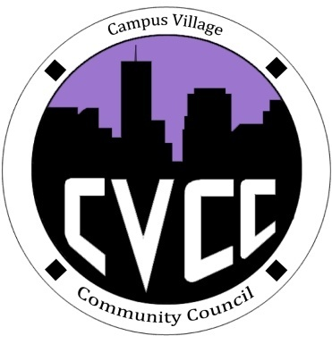

Community Council Agenda
Sunday, October 6, 2013

- Call to Order:
- Roll Call:
- President
- Vice-President
- Treasurer
- Secretary
- Marketing Coordinator
- Marketing Representative
- Icebreaker-Lana
- Unfinished Business:
- October Events
- Art Appreciation Week (Oct.7-10)
- Dart Art- October 7th from 7-9pm
- Caricature Night- October 8th from 7-9pm
- Canvas and Mocktails –October 9th from 7-9pm
- Townhall/Edible Art/Art Contest- October 10th @7pm
- Halloween Dance: October 24 @ 8pm
- Executive Board Member Updates
- Recycling Project
- New Business:
- SAVE THE DATE: Lynx Leadership Conference- Jan.16, 2014
- CVCC Elections
- Budget update
- Funding Requests
- From the Floor:
- Advisor Remarks:
- Adjournment:

