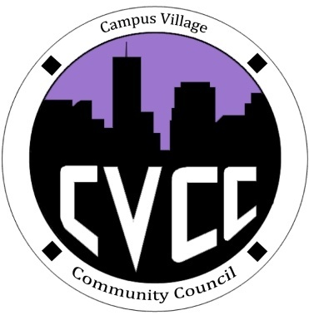

Community Council Agenda
Sunday, September 29, 2013

- Call to Order:
- Roll Call:
- President
- Vice-President
- Treasurer
- Secretary
- Marketing Coordinator
- Icebreaker-Lana
- Unfinished Business:
- Funding Requests
- RA Brian
- RA Halley
- September Events
- Hike at North Table Mountain Evaluation
- October Events
- Art Appreciation Week (Oct.7-10)
- Dart Art- October 7th
- Caricature Night- October 8th from 7-9pm
- Canvas and Mocktails –October 9th
- Townhall/Edible Art/Art Contest- October 10th @7pm
- Advertising efforts for week
- Halloween Dance: October 24 @ 8pm
- Ideas?
- New Business:
- Recycling Project
- Budget update
- Funding Requests
- Budget Proposal Sheet
- From the Floor:
- Advisor Remarks:
- Adjournment:

