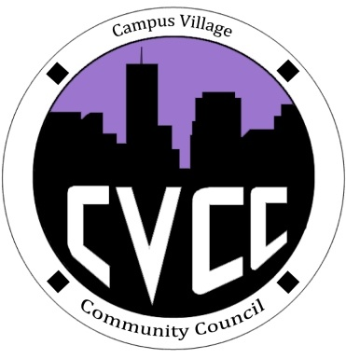

Community Council Agenda
Sunday, September 22, 2013

- Call to Order:
- Roll Call:
- President
- Vice-President
- Treasurer
- Secretary
- Marketing Coordinator
- Icebreaker- Cassandra
- Unfinished Business:
- Funding Requests
- Jenny Kim
- September Events
- Hike at North Table Mountain
- Saturday, Sept. 28 from 9am-2pm
- Boxed lunches (Sodexo)- $7.75 per person ($286.75 total)
- October Events
a. Art Appreciation Week (Oct.7-10)
b. Townhall: Thursday, October 10 @ 7pm
c. Halloween Dance: October 24 @ 8pm
- New Business:
- November Townhall: Thursday, November 14 @ 5:30pm
- Funding Requests
- Budget update
- CVCC Swag Proposal
- From the Floor:
- Advisor Remarks:
- Adjournment:

