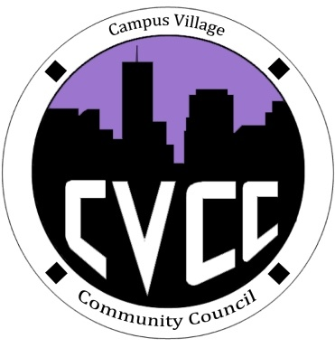

Community Council Minutes
Sunday, September 9, 2013

- Call to Order: 1:07pm
- Roll Call:
- President: Barbara Okuley
- Advisors: Amber Swartz and Russell Slendebroek
- General Assembly: 4
- Welcomes/Introductions
- Icebreaker- Aaron
- Human knot
- Unfinished Business:
- September Events
- Townhall Meeting: Thursday, September 12 @ 5:30pm
- Set up- 5:00pm
- Arrival/Welcome- 5:30pm
- Food- 5:45pm
- Discussion- 6:00pm
- Introduction/ 1 like and 1 dislike
- Hike to Red Rocks: Saturday, September 28 from 9:30am to 3:00pm
- Meet in Lobby- 9:30am
- Back to CVA- 3:00pm
- Sign-up at front desk after Townhall
- Set up meeting with Tad about Lunches to go
- Backup plan LightRail if passage vans do not work
- New Business:
- Ideas for upcoming events
1. Girl intramural sports based on floor
2. Financial Speakers about how to budget
  - Banking 101
- Practical programs for different niches
- Art Gallery
  - Seminars
  - Finger Painting
  - Balloons with Darts
  - Art Gallery
- Different Venues?
- Open Mic Nights

- Budget update: $800.00
- Funding Requests: None
- Application update
- From the Floor:
- IACURCH update
- Adjournment: 2:23pm

