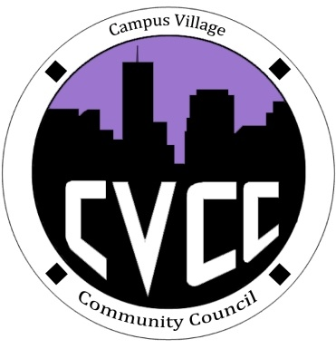

Community Council Agenda
Sunday, September 9, 2013

- Call to Order:
- Roll Call:
- Welcomes/Introductions
- Icebreaker- Aaron
- Unfinished Business:
- September Events
- Townhall Meeting: Thursday, September 12 @ 5:30pm
- Hike to Red Rocks: Saturday, September 28 from 9:30am to 3:00pm
- New Business:
- Ideas for upcoming events
- Budget update
- Funding Requests
- Application update
- From the Floor:
- Adjournment:

