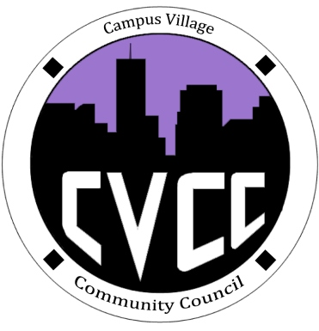

Community Council Minutes
Sunday, August 25, 2013

- Call to Order: 1:07pm
- Roll Call: Barbara Okuley, Amber Swartz, Russell Slendebroek, Lana Bilbo
- Funding Requests: None
- Thought of the Day: Barbara Okuley
- “Opportunity is missed by most people because it is dressed in overalls and looks like work.” –Thomas Edison
- Unfinished Business: None
- New Business:
- Welcome/Introductions
- CVCC Goals
- CVCC presentation
- Ideas for upcoming events
- Hikes, taking the bus
- Saturday, Sept. 28th
- Red Rocks
- Lunch to go
- Skiing trip
- Halloween week/Dance
- Budget update
- ~$500.00
- Recruitment update
- Applications due September 1st
- From the Floor:
- More advertising for programs
- Stairwells, Doors, etc.
- More prominent in the weekly newsletter
- Lana
- Sign-ups for getting members more consistent
- UHL students want to get involved/heavily recruit
- Financial Workshop for students
- Adjournment: 1:57pm

