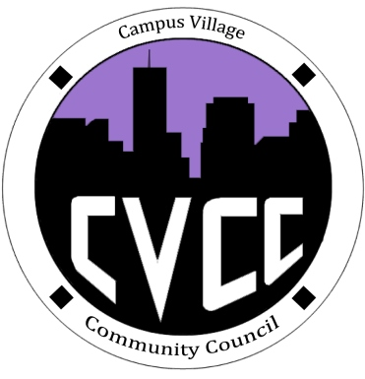

Community Council Agenda
Sunday, August 25, 2013

- Call to Order:
- Roll Call:
- Funding Requests:
- Thought of the Day: Barbara Okuley
- Unfinished Business:
- New Business:
- Welcome/Introductions
- CVCC Goals
- CVCC presentation
- Ideas for upcoming events
- Budget update
- Recruitment update
- From the Floor:
- Adjournment:

