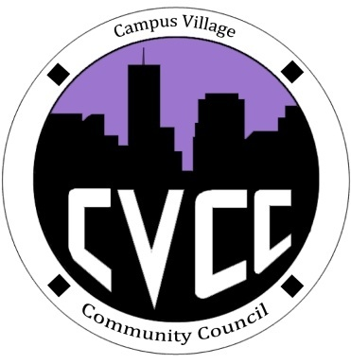

Community Council Minutes
Friday, March 14, 2014

- Call to Order:
- Roll Call:
- President
- Vice-President
- Treasurer
- Secretary
- Marketing Coordinator
- Marketing Representative
- Financial Report
- Budget Update
- Funding Requests
- Unfinished Business:
- Townhall Meeting: Tuesday, March 18th at 7pm in the Classroom
  - Set-up at 5pm
- CVCC Engagement: Tuesday, April 1st at 7:30pm in the Classroom
  - Voodoo Donuts
- Spring Dance: Friday, April 18th
  - Will Card- resident hosting event
  - CVCC-support financially and volunteer for event
- StrengthsFinder
- Floor Representative Update
- New Business:
- No Engagement on Tuesday, March 25th
- No E-Board meeting on Friday, March 21st and 28th
- From the Floor:
- Advisor Remarks:
- Adjournment:

