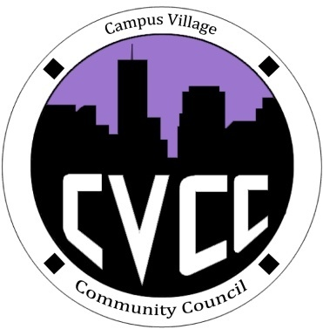

Community Council Agenda
Friday, February 14, 2013
Happy Valentine’s Day

- Call to Order:
- Roll Call:
- President
- Vice-President
- Treasurer
- Secretary
- Marketing Coordinator
- Marketing Representative
- Financial Report:
- Budget Update
- Funding Requests
- Unfinished Business:
- CVCC Engagement- Tuesday, Feb.18 at 7:30pm in the Classroom
- Chocolate event from 7pm-9pm
- Townhall Meeting- Thursday, Feb. 20 at 7pm in the Classroom
- Aaron-Soul Food Budget Proposal
- New Business:
- CVCC Recruitment
- From the Floor:
- Advisor Remarks:
- Adjournment:

