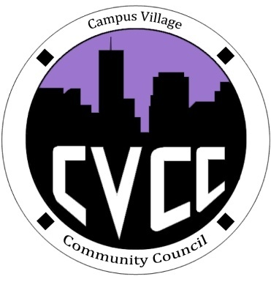

Community Council Agenda
Friday, February 4, 2013

- Call to Order:
- Roll Call:
- President
- Vice-President
- Treasurer
- Secretary
- Marketing Coordinator
- Marketing Representative
- Unfinished Business:
- Super Bowl PartyEvaluation
- CVCC Polo and Sweatshirt Budget Proposal
- CVCC Engagement- Tuesday, Feb.11 at 7:30pm in the Classroom
- CVCC Engagement-Ice Cream Social Budget Proposal
- New Business:
- Townhall Meeting- Thursday, Feb. 20 at 7pm in the Classroom
- StrengthsFinder
- Budget Update
- CVCC Engagement-Movie Ticket Budget Proposal
- Funding Requests
- From the Floor:
- Advisor Remarks:
- Adjournment:

