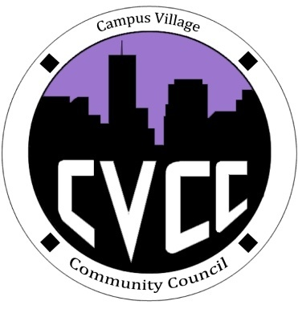

Community Council Agenda
Sunday, January 26, 2013

- Call to Order:
- Roll Call:
- President
- Vice-President
- Treasurer
- Secretary
- Marketing Coordinator
- Marketing Representative
- Unfinished Business:
- Super Bowl event
- CVCC Polo and Sweatshirt Budget Proposal
- Promotional item Budget Proposal
- New Business:
- Budget Update
- Funding Requests
- New Business Meeting Day Proposal
- Meeting Materials Proposal
- From the Floor:
- Advisor Remarks:
- Adjournment:

